{{#TwitterFBLike:right|small|like}}

Create a wiki topic page (your title)

Summary
Use this template to create a basic topic for WikiSea. Do not insert any graphics.
To use this template, install the Microsoft Word Add-In found at:
https://www.microsoft.com/en-us/download/details.aspx?id=12298
To export the finished topic to WikiSea:
- Save the document using Save As and select the file type Mediawiki (*.txt)

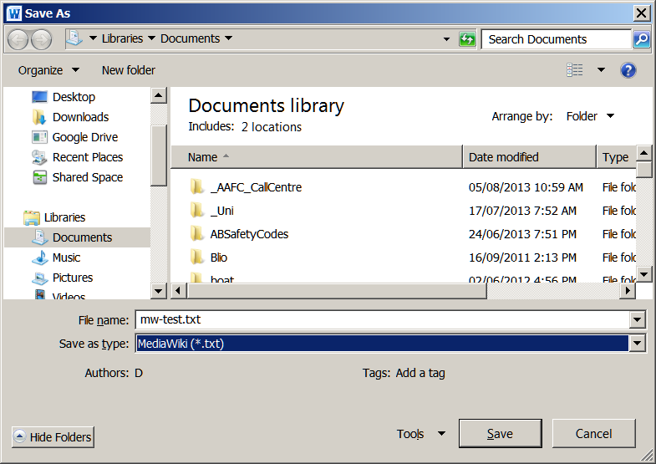

- Name and create a wiki page for your topic.
- Open the txt file and copy paste the contents into your wiki topic page.
- Save the wiki page.

Introduction
Para text

Para text

- Bullet list
- Bullet list
- Bullet list

- Numbered List
- Numbered List
- Numbered List

Another Subhead Level 2
Para text

Para text

Another Subhead Level 3
Para text

Para text

Weblinks
Para text

References
Para text

